**LAB 07 – PS**

Sandeepa M S IT24100400

1. 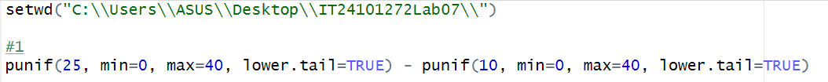

02)





03)

[i]





[ii]



